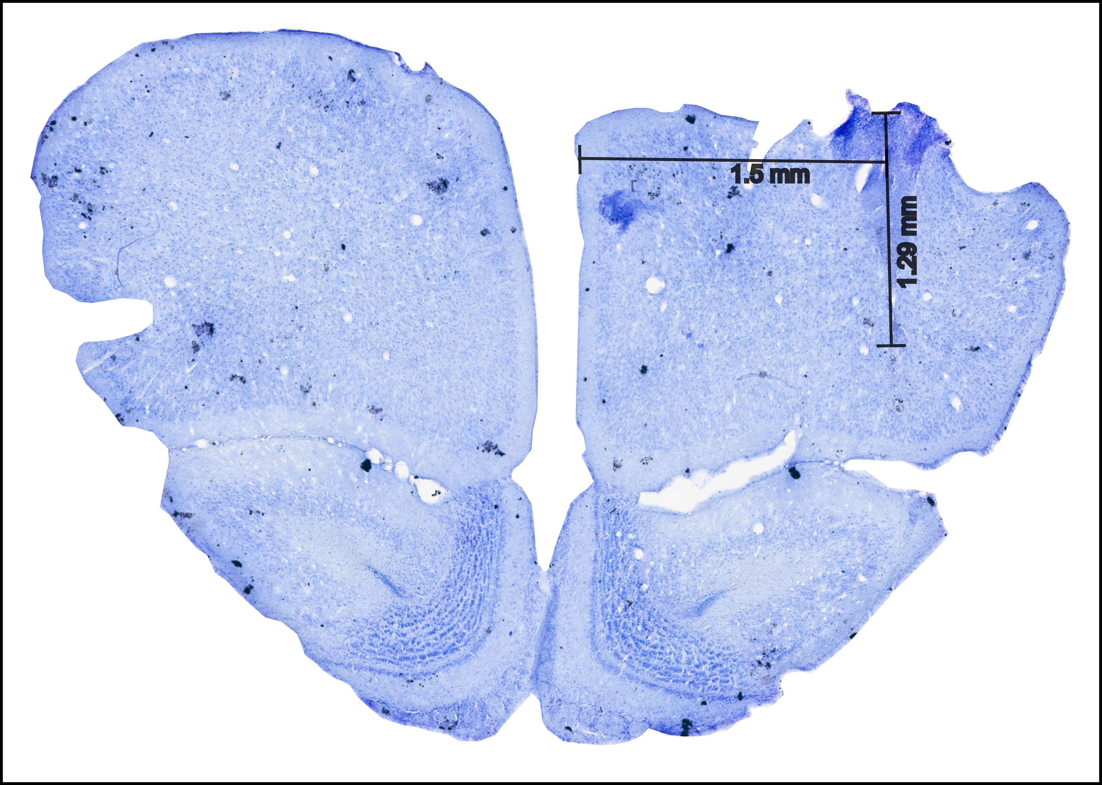

**Figure 1: Grand CSD**

1. **Almost similar travel time after session 5**
2. **Median ± SD pokes before leaving**
3. **Mean rewarded and unrewarded pokes based on starting probability**

**Figure 2: Behavioural results**

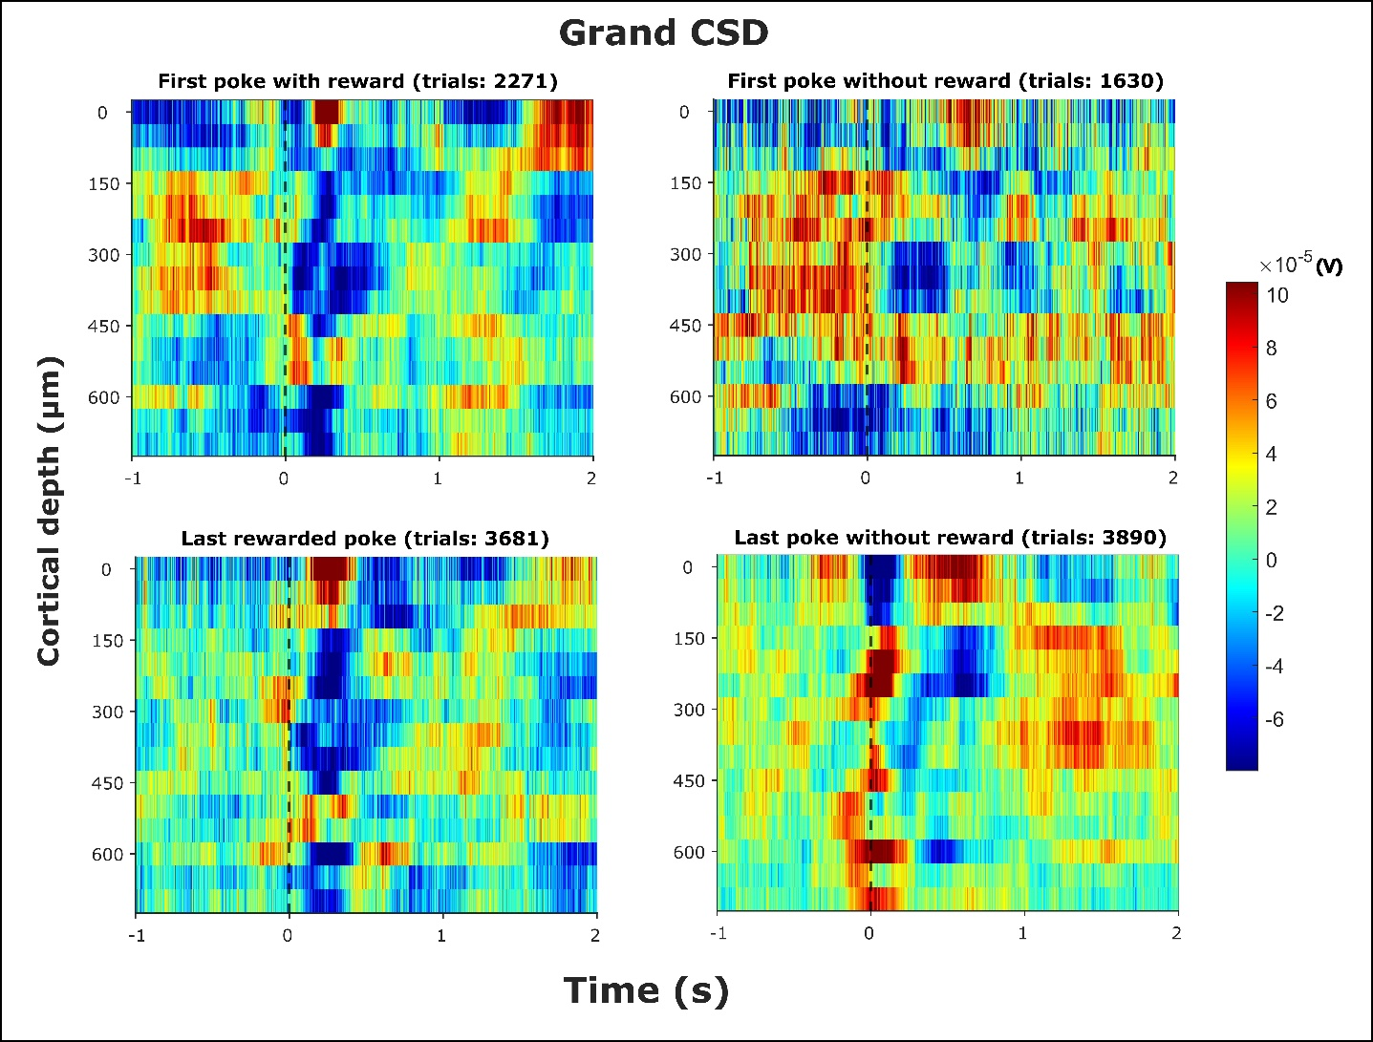

**Figure 3: Grand averaged CSD (n=5)** – The selected epochsrepresent -1 to +2 seconds from the end of the poke (black dashed line). The selected epochs were taken for four different events (pokes) and its corresponding consequence (reward): (top left) first poke with reward, (top right) first poke without reward, (bottom left) last rewarded poke, and (bottom left) last poke without reward.

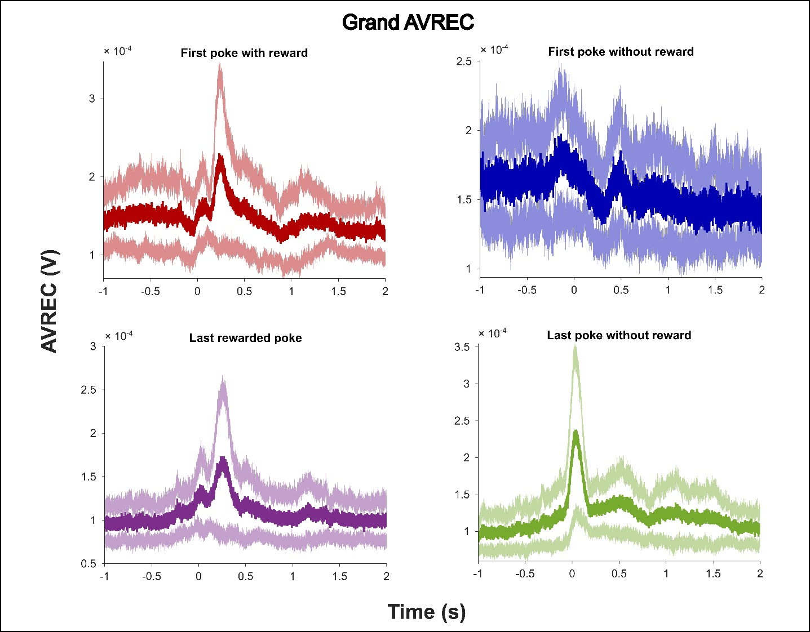

**Figure 4: Grand averaged AVREC (n=5)** – The selected epochsrepresent -1 to +2 seconds from the end of the poke. The selected epochs were taken for four different events (pokes) and its corresponding consequence (reward): (top left) first poke with reward, (top right) first poke without reward, (bottom left) last rewarded poke, and (bottom left) last poke without reward.

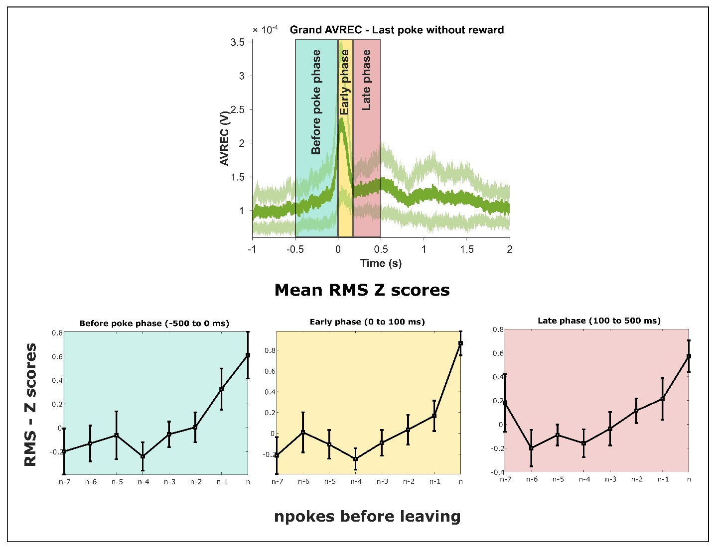

**Figure 5: Mean RMS Z scores** – The mean RMS Z score was computed for all the unrewarded pokes from the last rewarded poke until the last poke (n) before leaving the current spout. From the grand averaged AVREC (top), three different epochs were selected to compute the RMS: before poke phase (-500 to 0 ms), early phase (0 – 100 ms), and late phase (100 – 500 ms).

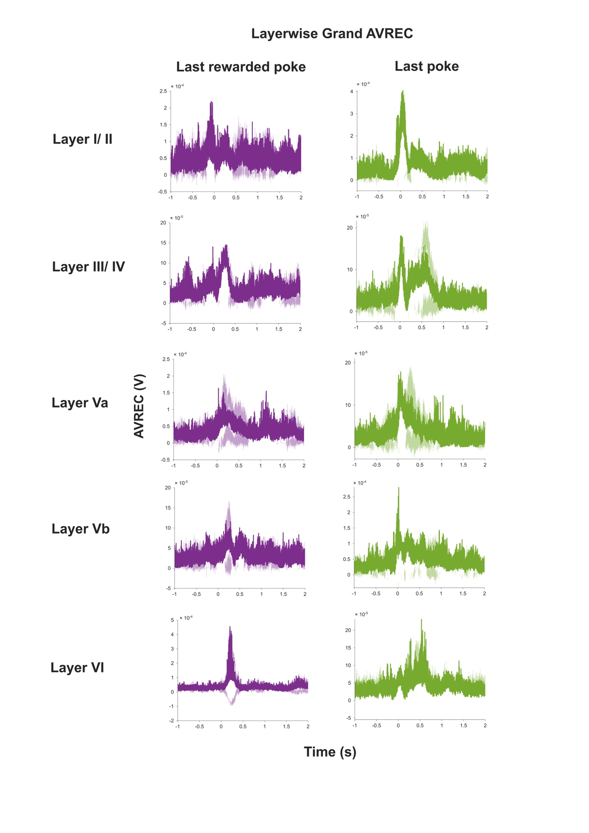

**Figure 6: Layer wise grand averaged rectified sinks (n=5)** – The rectified sinks was computed for all the identified layers from the CSD profile (Figure 3). The selected epochsrepresent -1 to +2 seconds from the end of the poke (t = 0). The selected epochs were taken for last rewarded poke and last poke without reward.

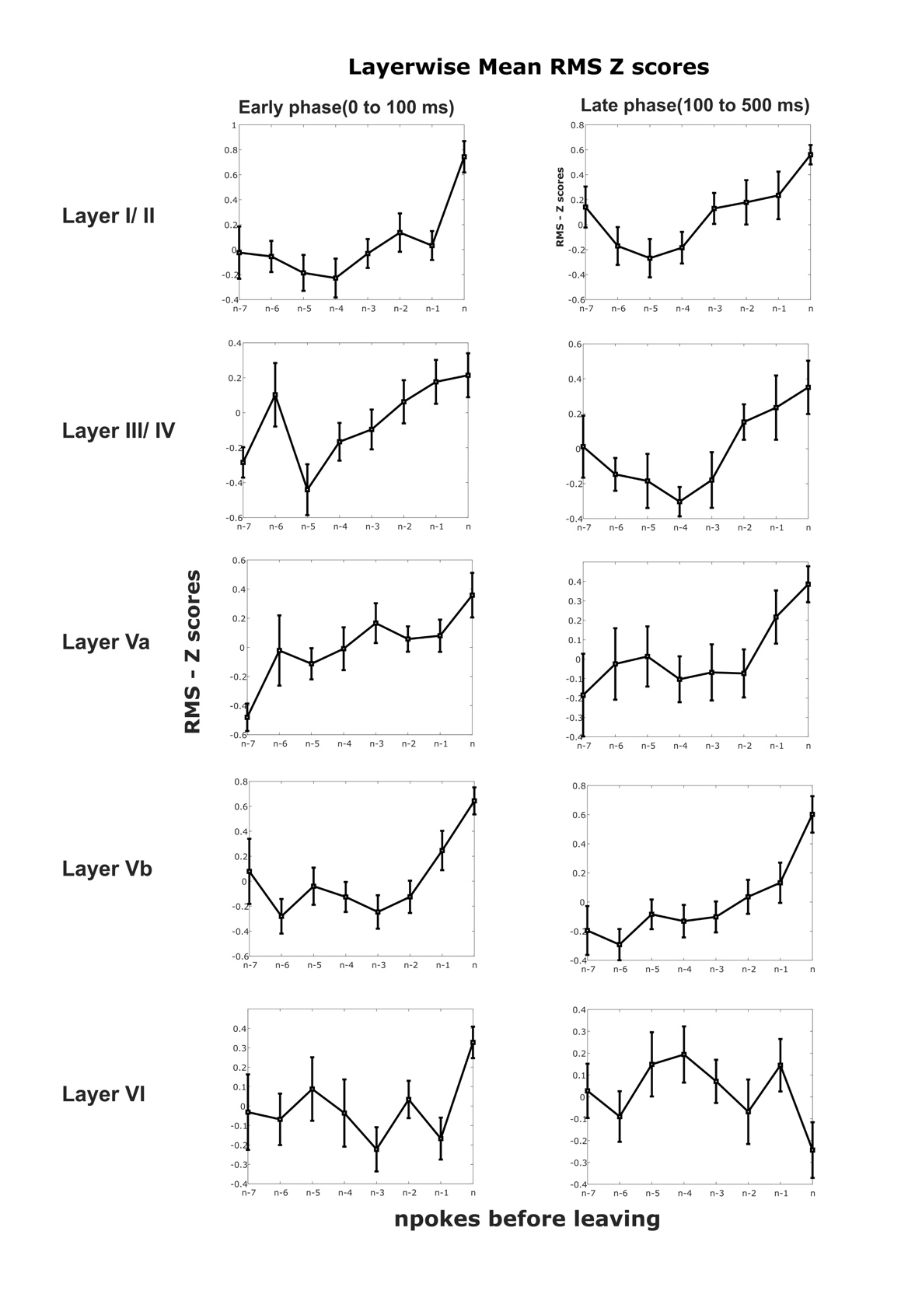

**Figure 7: Layer wise mean RMS – Z scores** – The mean RMS Z score was computed for the average rectified sinks for all the identified layers. The selected period involves unrewarded pokes from the last rewarded poke until the last poke (n) before leaving the current spout. Two different epochs were selected from the average rectified sinks (Figure 6) to compute the RMS: early phase (0 – 100 ms), and late phase (100 – 500 ms).